

**FACULTY OF ENGINEERING, SCIENCE AND TECHNOLOGY**

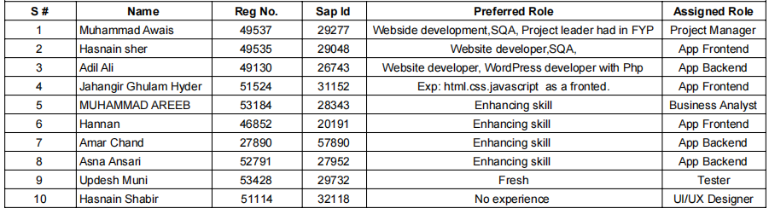**DEPARTMENT OF COMPUTER SCIENCE**

**ROJECT:**

**Shopkeeper Inventory and POS App**

**COORDINATOR NAME:**

**Daniyal Nawaz**

**Jan/26/ 2024**

**Software Requirement Specification for Shopkeeper Inventory and POS App**

1. **User Authentication and Access Control:**
   * **Description:**
     + The system should have a secure user authentication mechanism for shopkeepers.
     + Access control features should be implemented to ensure that only authorized users can perform specific actions.
2. **Functional Requirements:**
   * + Shopkeepers must be able to register and log in securely.
     + Different user roles (e.g., admin, cashier) with distinct access privileges.
     + Password encryption and secure session management.
3. **Non-Functional Requirements:**
   * + Response time for user authentication should be within X seconds.
     + The system should adhere to industry security standards for user data protection.
4. **Inventory Management:**
   * **Description:**
     + The system should facilitate effective management of product inventory.
   * **Functional Requirements:**
     + Shopkeepers can add, update, and delete products.
     + Real-time inventory tracking with notifications for low stock.
     + Barcode scanning functionality for quick product addition.
   * **Non-Functional Requirements:**
     + The system should support a minimum of X products in the inventory.
     + Inventory updates should reflect in real-time with a maximum delay of Y minutes.
5. **Point-of-Sale (POS) System:**
   * **Description:**
     + The app should provide a seamless point-of-sale experience for shopkeepers.
   * **Functional Requirements:**
     + Support for multiple payment methods (cash, card, digital payments).
     + Generation of receipts for completed transactions.
   * **Non-Functional Requirements:**
     + The average transaction processing time should be within X seconds.
     + The system should be available for POS operations at least 99.9% of the time.
6. **Barcode Scanning Integration:**
   * **Description:**
     + The app should integrate a barcode scanning feature to expedite product management.
   * **Functional Requirements:**
     + The system should recognize and process standard barcode formats.
     + Shopkeepers can use the device camera for barcode scanning.
   * **Non-Functional Requirements:**
     + The barcode scanning feature should have an accuracy rate of at least 98%.
     + Response time for barcode recognition should be within X milliseconds.
7. **Reporting and Analytics:**
   * **Description:**
     + The system should provide basic reporting and analytics features for shopkeepers.
   * **Functional Requirements:**
     + Generate reports on sales, popular products, and inventory levels.
     + Analytics dashboard for insights into business performance.
   * **Non-Functional Requirements:**
     + Report generation should be completed within X minutes.
     + The system should store historical data for at least Y months.

End!